XPilotPanel
XPilotPanel is open-source cross-platform meta server browser, client and server laucher, configuration editor for recent versions of XPilot of almost all branches.
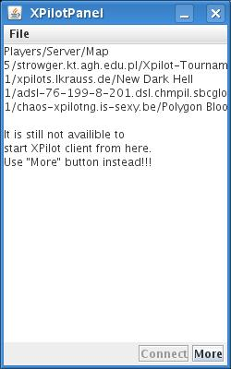
It looks like instant messenger:

But instead of “your contacts” there are servers.

Servers in main will be shown in JTree and divided into 3 categories:
- “Golden” servers(selected servers that are shown always, even when there's no one)
- Internet servers(only that, where someone is playing)
- Local servers

Servers are sorted by decreasement of number of players and number of servers of each group will be set in “Preferences”.

Button “Connect” will start XPilot client connected to server that is selected in hypothetical JTree area(on place of JTextArea, which temporary shows information about servers in text mode”).

Button “More” opens dialog window, where you can type what server/port(in 0.2 its broken, this bug needs fix) to connect or select server from such tabs(with full list of servers):
- “Golden” servers – saved servers to be always visible and manually added and saved servers by IP:port(planned to be in next version)
- Internet servers
- Local servers(local servers retrievement is still not implemented)

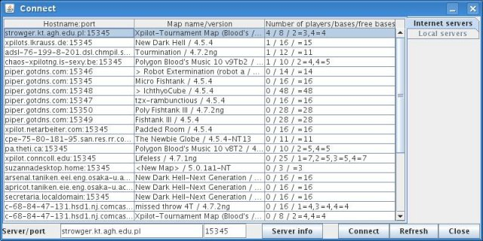

XPilotPanel should have icon in tray(for QT, GTK, Windows, etc.), but if tray isn't initialised closing main window will force minimising it(when tray is present – it just will become invisible).

There also should be configuration editor, which support few profiles of configuration of client options. Now we have “preferences” editor – it edits XpilotPanel's options and basic XPilot client ones.

Technologies requirements:
- The GNU General Public License should be used
- Java SE 6.0 should be used
- XML format should be used for storing preferences and data
- To store and read from XML files JAXB object-to-xml mapper(javax.xml.bind) should be used

Code style requirements:
- fully described javadoc comments should be placed everywhere(methods, fields, etc.)
- An “// $Id$” comment should be placed at the top of each file
- GNU GPL disclaimer should be placed after “// $Id$” and blank line should separate them
- Blank line should be at the end of each source and text file

